

Essentials Mathematics

Unit 3

Investigation #3

Ramps

A ramp is an inclined, flat access way between one level and another. Ramps are particularly important for persons with mobility issues who have difficulty accessing stairs, such as those persons with physical impairment or who use a wheelchair.



Standard ramps have an inclined access way with a gradient (slope) steeper than 1 in 20 (Diagram 1), but not steeper than 1 in 14 (Diagram 2).

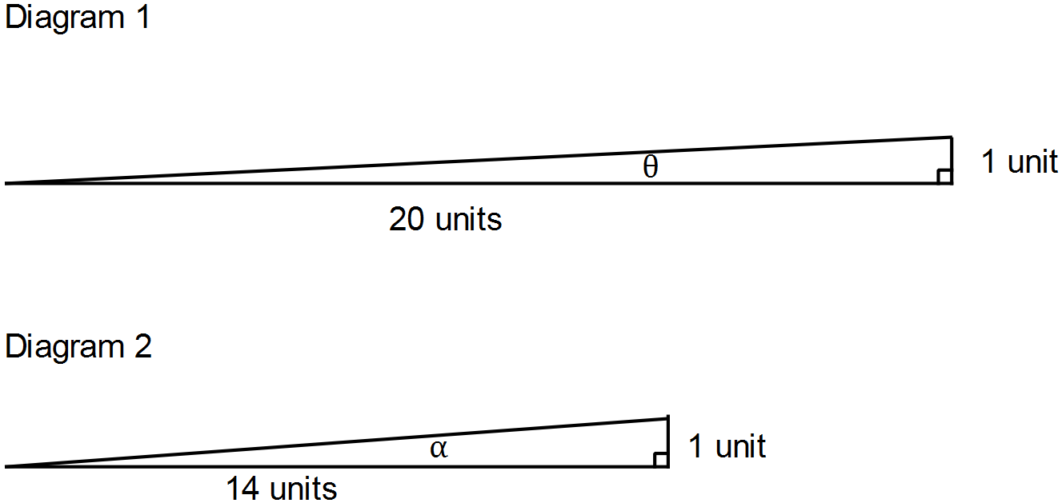

This standard could be interpreted in terms of the angle of inclination of each ramp.

**Question 1:**

The size of the angle of inclination θ of the ramp in Diagram 1 is 2.9° to one decimal place. Compare the size of this angle to the angle of inclination α of the ramp in Diagram 2. (3 marks)

**Question 2:**

If a ramp with the minimum gradient is needed to reach a height of 60 cm, how long would the ramp need to be? (3 marks)

**Question 3:**

A planner wants to decide the most appropriate horizontal length to be taken up by a ramp leading to the entrance of a building. The ramp needs to reach a vertical height of 0.6 m. Compare the length of the horizontal distance of the two ramps, one with minimum slope and one with maximum slope. (4 marks)

The current Building Code of Australia requires a ramp to have level landings every nine metres of the **slant** distance.

**Question 4:**

Would either of the ramps in question 3 need to include a level landing to comply with the Building Code of Australia? Explain your answer. (6 marks)